UTILITY TRAILER MAINTENANCE GUIDE

Please read all of the following material carefully. If you have a question regarding any of this material, contact your fleet manager or dealer for further assistance. State laws vary so check to make sure you are in compliance with the regulations applying to brakes, licenses and weights. When lowering gates, have one person on each side of the gate and lower slowly and cautiously.

1. *SELECTING THE PROPER TRAILER*

The most important aspects of trailer selection is selecting the proper weight capacity. Improper weight capacity can lead to excessive tire wear, abnormal wearing of parts, brakes and trailer structure damage. To determine the proper capacity add the weight of all equipment, parts, etc. Once this number is totaled, add a 10% safety margin then an adequate weight carrying capacity can be determined.

1. *TRAILER MAINTENANCE & STORAGE*

Lubricate moving parts such as the tongue jack, coupler and ramps with a quality lubricant. This helps keep these parts working properly and extend their life. Tires lose air when they sit for extended periods. Each time before towing check your tires for proper tire inflation “when cold”. If you check after the tires are warmed up then the pressure reading will not be accurate. Low tire pressure can lead to excessive tire wear & blowouts. Lubricate your trailer hubs at least monthly.

1. *TRAILER BRAKES*

Laws on trailer brakes vary from state to state. Some states require brakes on trailers grossing as little as 1500 pounds. The electric brake controller with a 7 way electrical plug equipped in the towing vehicle operates the electric brakes on the trailer. Test your trailer brakes each time for proper operation. If the brakes are not working properly, check for improper or cut wiring. Only a qualified establishment with experience in trailer brake systems should repair the trailer brakes. The vehicle’s brake controller can be adjusted as necessary for proper braking*.*

1. *TRAILER LOAD CARRYING CAPACITY*

Each trailer is equipped with a manufacturer’s vehicle identification tag. This tag is located near the front of the trailer on the frame. This tag states all of the trailer information required by law including tire information and pressure and carrying capacity. Make sure you have more than enough capacity for the total weight of the equipment loaded on the trailer.

1. *TRAILER & LOAD INSPECTION*

Check overall condition of the trailer:

* load is securely tied to the deck with tie downs and properly distributed for weight
* ramps are in towing position and all pins or latches are in the proper position
* deck is free of debris
* tongue jack is fully retracted in the up position
* all fasteners, hardware, brackets, frames, flooring are secure

Replace/repair any questionable item before using trailer.

1. *COUPLER*

Verify that the hitch ball size of the coupler and the towing vehicles hitch ball are the same size. Failure to do this could result in the trailer detaching from the towing vehicle. The ball size is listed on the top of the trailers coupler or actuator. Securely latch the coupler onto the towing vehicles hitch ball, making sure the coupler is secure on the hitch ball. Place a safety pin or lock on the coupler latch to prevent the coupler from opening while towing.

1. *SAFETY CHAINS*

Trailers are equipped with safety chains at the front of the trailer. Make sure there is slack for cornering. These chains attach to your towing vehicles hitch and are essential in the event of trailer / towing vehicle separation. It is procedure to “cross” the chains under the coupler. In the event of separation, this may keep the trailer from hitting the ground before you are able to stop safely.

1. *TOWING*

The added weight of towing a trailer requires a greater stopping distance. Be sure to maintain a safe distance between you and other vehicles when towing. It is recommend generally traveling and towing at slower speeds.

1. *WHEEL LUG NUTS & AXLES*

Each time before towing check lug nuts for proper tightness. Torque settings: 90 pounds. If lugs become rusty, replace before towing. Each axle has a different rating depending on weight capacities. If axles should become bent, cracked or damaged in any way, replace with duplicate capacity axle before towing.

1. *TIRES & INFLATION*

Each time before towing check all tires for proper inflation when the tire is cold. Inflation ratings are listed on the tire sidewall. If there is excessive tire wear, do not tow until correction/replacement is completed. Carry a proper weight jack, spare tire & wheel, spare hub & bearings in case of failure.

1. *TRAILER LIGHT SYSTEM*

Check each trailer light to make sure they are working properly before each towing. If lights are not working properly, check bulbs or wiring and take corrective measures. The contacts may become corroded and therefore not allow electric current to the lights. A simple movement of the light against the contact will usually re-gain light function.

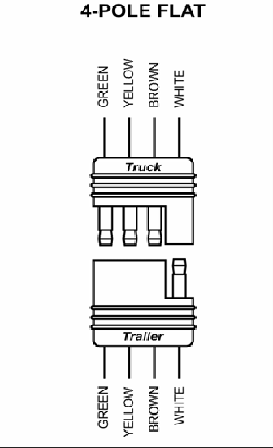

*STAY CLEAR OF RAMPS OR GATES WHEN LOWERING!

7 WAY PLUG WIRE CODE / TRAILER END:

The information in this document was obtained from sources which, to the best of the writer’s knowledge, are authentic and reliable. Alliant Insurance makes no guarantee of results and assumes no liability in connection with either the information or recommendations obtained in this document. Moreover, it cannot be assumed that every acceptable procedure is included in this document or that abnormal or unusual circumstances may not warrant or require further or additional procedures.

|  |  |  |  |
| --- | --- | --- | --- |
| **#** | **Color** | **Circuit Function** | **connector interior** |
| 1 | white | Common ground | [7 way connector] |
| 2 | blue | electric brake |
| 3 | green | tail/running lights |
| 4 | black | battery charge (+) |
| 5 | red | left turn/stop |
| 6 | brown | right turn/stop |
| 7 | yellow | auxiliary/back up |